**A TECHNICAL REPORT**

**ON**

**STUDENTS INDUSTRIAL WORK EXPERIENCE**

**(SIWES)**

**UNDERTAKEN AT**

**RIVERS STATE ICT DEPARTMENT, SECRETARIAT, POINT BLOCK, 1ST FLOOR PORT-HARCOURT**

**BY**

**CHUWKUEMEKA-EZEH, ESTHER CHINENYE**

**21010306008**

**SUBMITTED TO**

**THE DEPARTMENT OF COMPUTER SCIENCE AND MATHEMATICS**

**MOUNTAIN TOP UNIVERSITY, MFM PRAYER CITY, IBAFO, OGUN STATE**

**IN PARTIAL FULFILMENT FOR THE AWARD OF BACHELOR OF SCIENCE DEGREE (B. Sc.) IN SOFTWARE ENGINEERING**

**INDUSTRIAL BASED SUPERVISOR: ENGR. FIENEMIKA REGINALD**

**INSTITUTIONAL BASED SUPERVISOR: PROF. E.A. OFUDJE**

**OCTOBER, 2024**

**DECLARATION**

I hereby declare that I have authored this SIWES report and it reflects my personal experience. It has yet to be previously submitted for a higher degree at this or any other university. All citations and sources of this information are acknowledged through references.

**____________________________________ ________________________**

**Chukwuemeka-Ezeh Esther Chinenye DATE**

**CERTIFICATION**

This is to certify that the content of this SIWES Report undertaken at the Rivers State ICT department, Secretariat, Point Block, first floor was prepared and submitted by CHUKWUEMEKA-EZEH ESTHER CHINENYE in partial fulfilment of the requirements for the degree of BACHELOR OF SCIENCE (B. Sc.) IN SOFTWARE ENGINEERING.

CHUKWUEMEKA-EZEH ESTHER CHINENYE DATE

EKUNDAYO GABRIEL HUNSIPE DATE

(DEPT. SIWES COORDINATOR)

**______________________________ __________________**

DR. A. A. MEBAWONDU DATE

(HEAD OF DEPARTMENT)

**DEDICATION**

This work is humbly dedicated to God Who saw me through the entire program and ensured my completion, and my friends and family members who displayed immense support throughout the program.

**ACKNOWLEDGEMENT**

I would like to express my deepest appreciation to everyone who contributed to the successful completion of this internship programme. First and foremost, I am immensely grateful to my company-based supervisor, Engr. Fienemika Reginald, whose guidance and teachings were instrumental in my learning experience during my stay. Also, my instituion-based supervisor, Prof. E.A. Ofudje whose timely assistance and valuable feedback were of great help.

I would also like to thank my colleagues Zuriel Akem, Akachuwku Emperor, and Walter Ibiene who made learning and working together a beautiful and competitive experience.

Lastly, I am indebted to my family and loved ones for their unwavering support and understanding during this project.

**TABLE OF CONTENTS**

Cover Page --------------------------------------------------------------------------------- i

Certification --------------------------------------------------------------------------------ii

Declaration --------------------------------------------------------------------------------iii

Dedication----------------------------------------------------------------------------------iv

Acknowledgments-------------------------------------------------------------------------v

Table of Contents ---------------------------------------------------------------------vi-vii

Table of Figures--------------------------------------------------------------------------viii

Report overview---------------------------------------------------------------------------ix

**CHAPTER ONE** -------------------------------------------------------------------------9-10

**1.0 SIWES OVERVIEW**

1.1 Introduction to SIWES

1.2 Importance of SIWES

1.3 Aims and Objectives of SIWES

**CHAPTER TWO**-----------------------------------------------------------------------11-14

**2.0 COMPANY OVERVIEW**

2.1 Introduction of the Company

2.2 Objectives of the Company

2.3 Organisational Structure of the Company (Organogram)

2.4 Core Operations of the Company

**CHAPTER THREE ---------------------------------------------------------------------**14-30

**3.0 SPECIFIC ASSIGNMENT (WORK DONE)**

3.1 Network diagnostics

3.2 Management Information System Implementation and Management

3.3 Data Analysis

**CHAPTER FOUR ---------------------------------------------------------------------**31-32

**4.0 CONCLUSION**

4.1 Knowledge Gained (Experience Acquired)

4.2 Challenges Experienced

4.3 Recommendations

**REFERENCES** --------------------------------------------------------------------------- 33

**REPORT OVERVIEW**

This industrial training report covers the work undertaken, knowledge, skills, abilities, projects and activities performed during the six-month Industrial Training program. The Student Industrial Work Experience Scheme (SIWES) was fulfilled at the Rivers State Information and Communication (ICT) Department, at the Rivers State Secretariat Complex, Point Block, First floor, Port Harcourt, from March 2024 to August 2024.

The nature of work undertaken ranges from the implementation of the Rivers State Public Service Management Information System (RIVPUSMIS), network diagnosis and troubleshooting to deep research on innovation and data analysis to improve decision making. This report also covers independent projects and personal skill development acquired from an online learning platform, Cisco.

This report contains all the information on the subject matter mentioned above and defines the experience gained. It also highlights the problems encountered during the duration of this training and recommendations that will help improve the purpose of the Industrial Training programme.

**CHAPTER ONE**

**1.1 INTRODUCTION TO SIWES**

The Student Industrial Work Experience Scheme (SIWES) was established by the Industrial Training Fund (ITF) in 1993. This scheme was designed to bridge the gap between theoretical knowledge gained in educational institutions and practical skills needed in the workplace. Its primary aim is to provide students with hands-on experience in real-world industrial settings increasing their skills, knowledge and employment rate.

Prior to the establishment of this scheme, university graduates in technical fields lacked practical experience making them less prepared for taking on job roles. This posed a great challenge for the students, graduates and the workforce in general. Addressing this challenge, the ITF initiated the SIWES program, which received the Nigerian Federal Government’s approval in 1974.

The primary objective of SIWES is to equip students with technical skills and hands-on experience in real-world industrial settings to make them acquainted with the workplace and employable. Through this program, students are exposed to industry-related challenges, build professional networks and gain insight into their chosen career path.

This scheme has become a mandatory programme for obtaining degrees or diplomas in certain disciplines. It is also a tripartite program involving the students, the tertiary institutions and the employers.

Participation in SIWES has now become a prerequisite for obtaining diplomas and degrees in specific disciplines at most higher education institutions in Nigeria, aligning with government education policies.

**1.2 IMPORTANCE OF SIWES**

The Student Industrial Work Experience Scheme is crucial in the development of technical and professional skills among students in Nigeria. This scheme is a significant tool for the national workforce as it ensures a smooth transition from the educational institution to the workplace. Not limited to providing students with practical knowledge and skills, it contributes greatly to national and economic growth.

This scheme bridges the gap between theory and practice, builds competence, improves employability, provides career clarification and opportunities and also prepares students for industrial challenges. These benefits are not only limited to the students but the employers also benefit from this initiative by recruiting graduates who are skilled and properly acquainted with the industrial setting.

**1.3 AIMS AND OBJECTIVES OF SIWES**

* It exposes students to real-world obstacles and industrial challenges.
* Through this scheme, students gain familiarity with industry-standard technologies and gain high-demand skills.
* This early exposure to the industry and its practices gives the students an edge in the competitive recruitment landscape after graduation.
* This scheme allows professional interaction with industry professionals, creating opportunities and a professional network.
* By producing a competent workforce, the economy of the country is improved.

**CHAPTER TWO**

**2.1 INTRODUCTION OF THE COMPANY**

The Rivers State Information and Communication Technology (ICT) was established in the year 2008 by the former Governor of Rivers State, Rt. Hon. Chibuike Rotimi Amaechi. During this regime, Mr. Good Leaf Mekini was appointed as the State Special Adviser (SSA) on ICT.

The primary function of this department is to automate major governmental processes including; the recruitment of staff, storing of state (Ministries Departments Agencies, MDA’s) records, biometrics, verification of staff and pensioners, and training of Rivers State residents on the use of ICT gadgets.

This department handles communication between the different MDAs using an enterprise network. Also, they are solely responsible for the development and maintenance of other MDA's websites.

However, the ICT department has recently been commissioned as a ministry with the new commissioner, Joe Johnson but the Special State Adviser for the department is still very active.

**2.2 OBJECTIVES OF THE COMPANY**

* To create and maintain an enterprise network infrastructure that provides network connectivity and email to all government offices in the state. It also functions as a technical support for the Rivers State government website.
* They provide regular workshop training for all civil/public servants, department interns, and state residents. This is to inform and expose the masses to Information and Communication Technology tools.
* To promote efficiency through the automation of government processes, functions and activities using Information and Communication Technology tools. These processes include; **RIVTAMIS, RIVPUSMIS, RIVCOMIS, RIVLAMIS, RIVHEMIS, AND RIVEMIS.**
* To develop and implement strategies to grow the information and communication technology sector in Rivers State and other related bodies to promote the adoption and use of Information Communication and Technology.
* To formulate policies on ICT implementation within the state to supervise state funds and also employment frauds like ghost staff.

**2.3 ORGANIZATIONAL STRUCTURE OF THE COMPANY (ORGANOGRAM)**

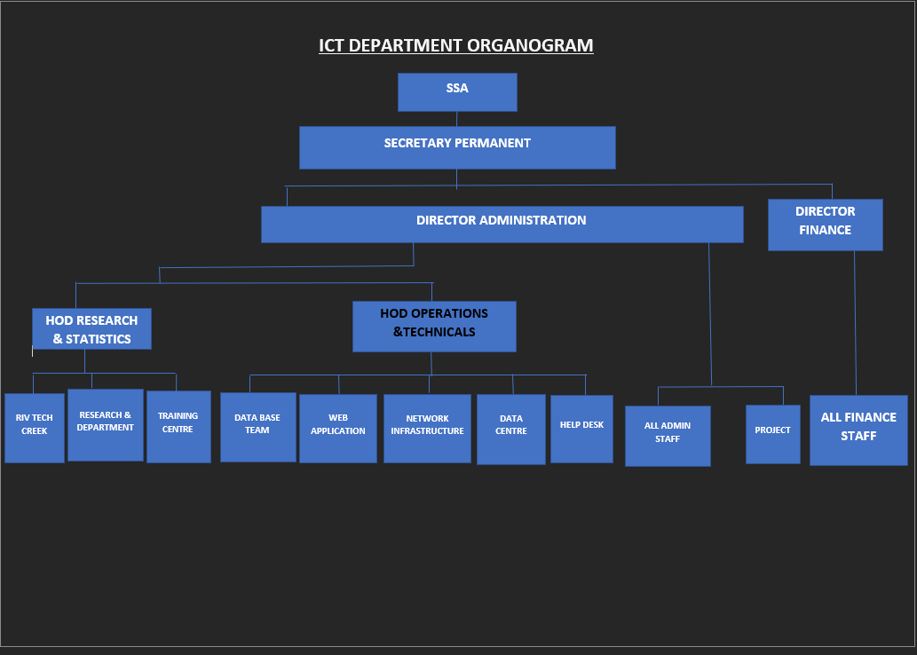

Fig 2.3.1 The organogram of the Information and Communication Technology Department of Rivers State.

**2.4 CORE OPERATIONS OF THE COMPANY**

The Rivers State Information and Communications Technology Department has six (6) core operations including technology adoption and innovative research, workshop training on ICT tools, database and biometrics, networking, repairs and maintenance, and web development.

1. Technology Adoption and Innovative Research: The backbone operation of all operations at the ICT Department is technology adoption and innovative research. The department carries out timely innovative research to automate government processes and activities. Through this operation, ideas and concepts are transformed into tangible products and solutions.
2. Workshop training on ICT tools: The Rivers State Tech Creek unit is specially created for this operation. They carry out training for civil servants, interns, and other state residents. Through this operation, employees are equipped with the knowledge and skills to enhance operational efficiency and address skill gaps.
3. Database and Biometrics: This operation is crucial to the verification and validation of staff on the Rivers State Public Service Management Information System(RIVPUSMIS). The department is in charge of this large database to keep records of all government workers in different MDAs.
4. Networking: This operation is important to ensure communication across all MDAs. The department has server rooms and other networking infrastructure to implement new networking solutions in the organization.
5. Repairs and Maintenance: The department uses this operation as a proactive approach to identify potential problems in systems or machinery to optimise performance, prevent security breaches, and ensure smooth operations.
6. Web development: The department is responsible for any website created for the different MDAs. Also, they ensure the websites are tailored specifically to the different MDAs, and their needs and automate their processes.

**CHAPTER 3**

**3.1 NETWORK DIAGNOSTICS**

Network diagnostics refers to identifying, analysing, and troubleshooting issues in a computer network to ensure a smooth performance. It encompasses a range of tools used to investigate and resolve network issues including; unusual traffic, bottlenecks, and different network anomalies.

The goal of network diagnostics is to quickly identify the root cause of network issues and apply solutions to restore optimal performance.

At the Network Infrastructure Unit, network diagnostics is an essential operation in maintaining and troubleshooting existing infrastructures using these key processes; network monitoring, fault detection and analysis, connectivity testing, hardware diagnostics, protocol analysis, and bandwidth and traffic analysis.

During my SIWES period, I assisted this unit to ensure network issues were identified and resolved quickly to maintain uptime and performance. I worked with the Traceroute on the Linux command line environment, and Wireshark to perform:

I. Network monitoring and analysis.

II. Network troubleshooting.

**NETWORK MONITORING AND ANALYSIS**

Network monitoring refers to the systematic tracking, analysis, and management of a computer network’s performance, security and operational status in real-time to ensure network availability and uptime. This network monitoring can be achieved using network protocol analyzers or monitoring software.

Using the network protocol analyser, Wireshark, I select the wifi adapter( Rivers ICT department ethernet) that I’m connected to and start capturing the traffic packets and packet contents. Doing this, the packets are displayed in real-time and various information such as source and destination IP address, protocol type and packet content. Once enough data has been captured, it is saved and exported to troubleshoot potential issues. To ensure data accuracy, Wireshark is run as an administrator and in a switched network, the switch must be configured to mirror the port.

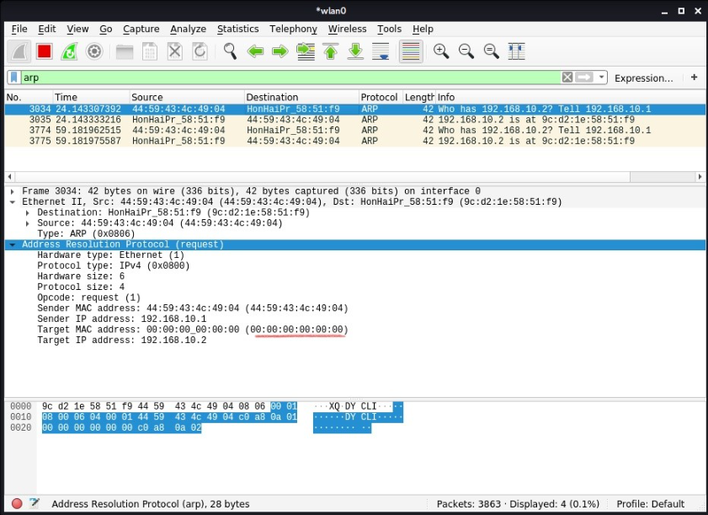

Fig 3.1.1 A snippet showing a network monitoring of packet capturing on an ethernet connection.

This screen snippet in Fig 3.1.1 shows different packets in an ethernet connection (River ICT department ethernet) using Wireshark.

Using Wireshark, I captured ARP (Address Resolution Protocol) packets to map IP addresses to MAC addresses within the local network. This action was taken to resolve incorrect routing configurations on devices with the inability to access the internet. Wireshark was used to observe network traffic, analyse the routing table for errors and confirm device configuration.

Incorrect routing configuration was a common networking challenge faced among devices. The network was continuously monitored by analyzing ARP packets to quickly identify these problems.

Also, there were cases of data packet transmission failure because they encountered routing loops. Routing loop refers to when a data packet is stuck in a cycle, bouncing back between routers without reaching its destination leading to network congestion and performance issues. This problem was resolved by using Wireshark to analyse the packets and routing tables for the source of the conflict.

**NETWORK TROUBLESHOOTING**

Network troubleshooting is the systematic process of identifying, analyzing, and resolving issues or problems within a computer network. It ensures optimal performance, reliability, and connectivity to minimize downtime and impact. This network troubleshooting can be achieved by logging and monitoring software, and command- line tools (i.e. ping and TraceRoute).

Using the Linux command-line utility, Traceroute, I start troubleshooting based on the information obtained from the protocol analyser. The Traceroute sends a series of packets to the target destination and maps the path. Traceroute on Linux or Tracecert on Windows is a common troubleshooting technique for locating routing problems and identifying bottlenecks and slow links. To run Traceroute effectively, it is used alongside a packet analyser, Wireshark, and it runs from different locations to isolate the problem to a specific network segment.

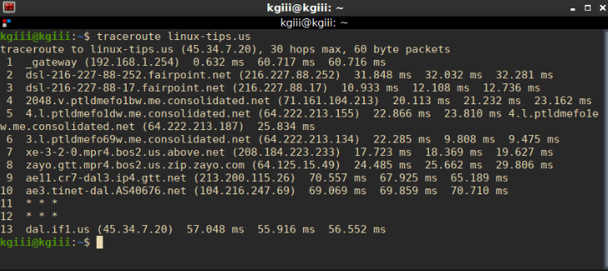

Fig 3.1.2 Using Traceroute as a network diagnostic tool to display hop numbers, IP address and Round-Trip Time (RTT)

The screen snippet in Fig 3.1.2 shows different paths which packets take to trace the route to [linux-tips.us](http://linux-tips.us) with each line represented as a hop. In the illustration above, it takes 13 hops(devices) between the device and the target site.

Using the Traceroute command, I identified some routing inconsistencies. The device was experiencing slow internet speed and poor performance, so I tracerouted to the popular Linux website. The results showed that some packets were getting stuck at a particular hop (eleven and twelve) and there was significant latency at that point. This simple operation suggests that there’s a problem with the router or the connection between that router and the next hop.

Traceroute is a common network troubleshooting utility that provides information about the route that data packets take to reach a destination. It provides valuable insights into network performance, routing issues, and packet loss.

**3.2 MANAGEMENT INFORMATION SYSTEM IMPLEMENTATION AND MANAGEMENT**

A management information system is a system used for decision-making, coordination, control, analysis, and visualisation of information in an organisation. The study of Management Information Systems involves people, processes and technology.

The goal of a Management Information System is to increase the value and profits of the organisation by empowering the managers with the information they need to make better decisions.

At the biometrics unit, I worked with the Rivers State Public Service Management Information System (RIVPUSMIS). It also has different access levels to control who can see and modify data for security and accuracy including; administrator, manager, and user. This system was made to keep records of all public staff across the different MDAs and to improve the credibility of the public service through biometrics and verification of new, existing, and retiring staff.

During my SIWES period, I worked with the RIVPUSMIS as an administrator to perform a specific operation, user account management.

**USER ACCOUNT MANAGEMENT**

User account management involves the processes of creating, managing, and controlling user accounts within a system. Also, it ensures that each user has the appropriate level of access and privileges based on their role and responsibilities. It is a crucial part of the system because it involves multiple users and sensitive data is involved.

Using the RIVPUSMIS, I performed several user account management tasks for new, existing, and retired staff. I performed user registration for users who weren’t registered in the system, updated staff documents like their school certificates, and uploaded documents for the retired staff to make them eligible for their pension allowance.

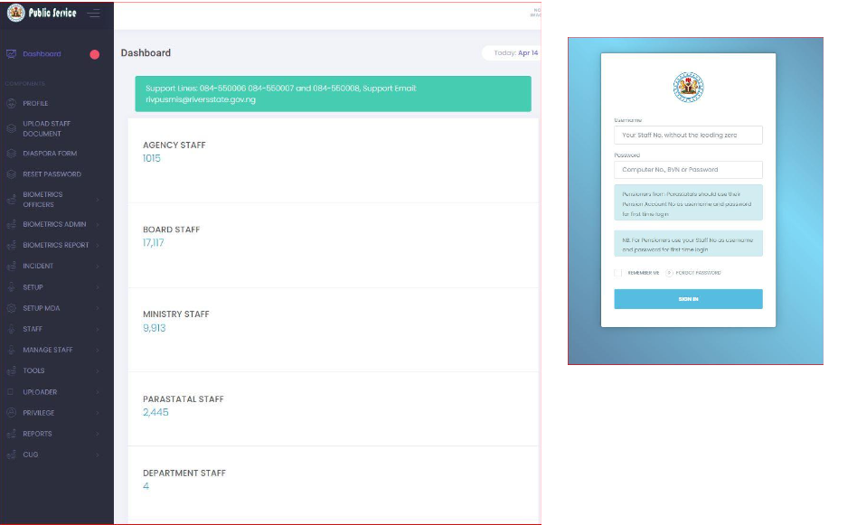

Fig 3.2.1 (a) The admin dashboard of RIVPUSMIS (b) The login page for RIVPUSMIS

The screen snippet above shows the admin dashboard and the login page for the Rivers State Public Service Management Information System (RIVPUSMIS).

The admin dashboard is segmented into two including; mainstream and pensioners. The mainstream is for new and existing staff while the pensioner segment is for retiring staff.

During my SIWES period, I worked with this dashboard as a biometric admin to verify and validate staff documents. Also, I performed critical operations like password reset, document upload, and different queries.

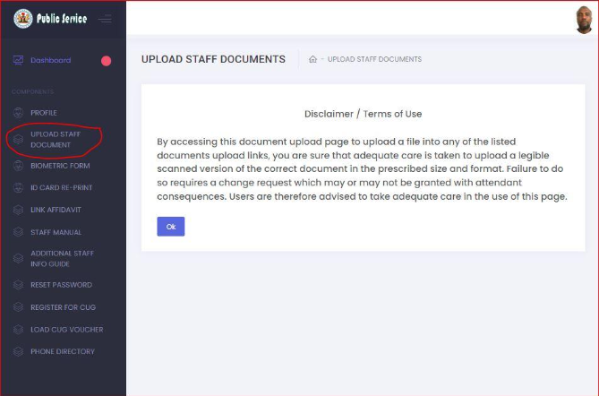

Fig 3.2.2 Basic staff document upload console.

I uploaded staff documents like school certificates for the mainstream staff and retirement letters for the pensioners. To upload documents as an admin, you need to get some information from the staff either staff ID or BVN. In cases where both are absent, the database is queried using a search by staff’s name. The query begins to iterate through the staff or pensioner table in the SQL database.

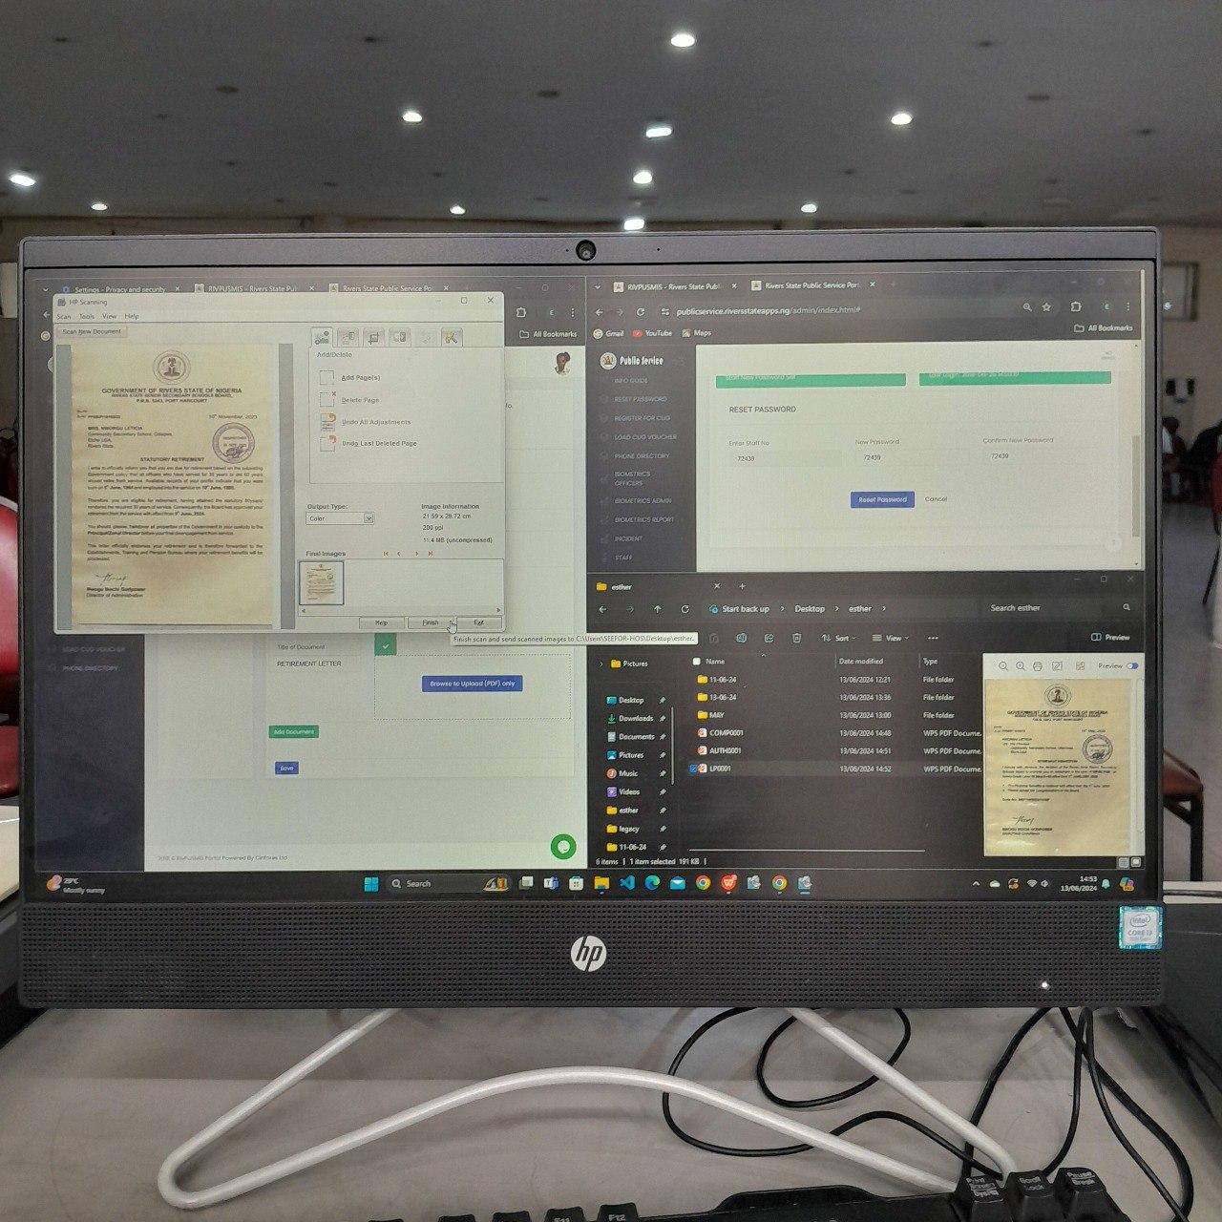

Fig 3.2.3 A screen snippet of different operations; password reset, document scanning and uploading.

After searching for a staff username, a password reset is carried out to access the Staff’s portal. Using the new login credentials, the staff’s dashboard is accessed and documents can be uploaded.

For accuracy, the documents scanned must be in a specific format (JPEG) and saved with a well-described title.

**3.3 DATA ANALYSIS**

Data analysis involves the systematic inspection, cleansing, transformation, and interpretation of data to discover meaningful patterns, draw conclusions, and support decision-making. This process employs a range of techniques to convert raw data into valuable insights.

Much like statistical analysis, data analysis is a crucial approach for organizations to gain insights from the vast amounts of data they collect. By scrutinising data using various tools and methodologies, data analysts can identify trends, relationships, and anomalies, leading to informed decision-making. These insights help organisations optimise processes, enhance customer experiences, and make predictions for future actions based on past data patterns.

During my SIWES period, I worked with Google colaboratory, and Microsoft Excel to perform different data analysis techniques including;

* Data Entry
* Data Cleaning & Sorting
* Data Visualization
* Data Export and Sharing

**DATA ENTRY**

Data entry refers to manually entering information into a computer database or spreadsheet. During my SIWES period, I used Microsoft Excel for this process. Microsoft Excel served as an excellent data entry tool due to its unique features for data entry including; data validation, conditional formatting, autofill and auto-format, and power query.

The primary goal of data entry is to accurately and efficiently transfer information into a computer system or database, ensuring data integrity and usability.

In Microsoft Excel, I efficiently entered data into well-structured columns and rows using its user-friendly interface. I ensured data accuracy and consistency through tools like data validation and cell formatting. Any errors or inconsistencies were promptly corrected to preserve data integrity and interpretability for future analysis.

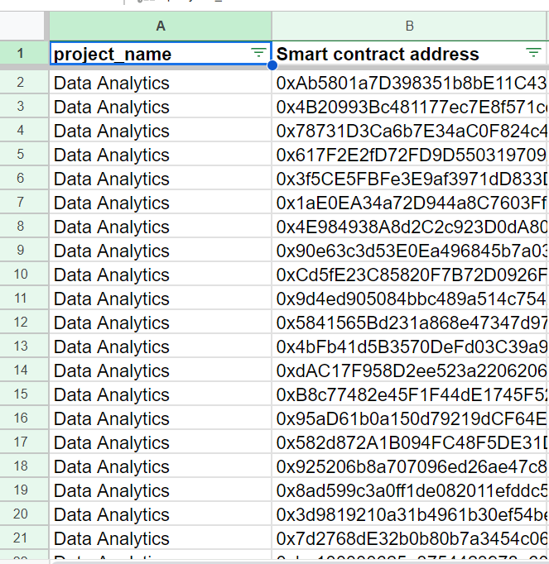

Fig 3.3.1 A screen snippet of my Excel sheet of data entered in different columns.

The Excel spreadsheet above shows data entered in different columns of about 400 entries.

The data was obtained from research from different relevant sources and compiled in a spreadsheet. I used cell formatting to ensure data validation, and I also avoided manual calculations by using formulas for calculations and automated processes.

**DATA CLEANING AND SORTING**

Data cleaning is the process of identifying, correcting, and transforming raw data into consistent, accurate, and reliable information. Data sorting is the process of arranging data in a specific order, making it easier to analyze, visualize and understand.

The primary goal of data cleaning and sorting is to remove errors and inconsistencies to improve data accuracy.

**Microsoft Excel:** Excel provided a powerful suite of sorting tools that enabled me to systematically arrange data based on specific criteria. By sorting data into ascending or descending order according to relevant columns, I created structured datasets that greatly enhanced the clarity of information. This not only improved the visual presentation of data but also facilitated subsequent analysis. For instance, sorting the smart contract addresses by exploiting occurrences allows a more insightful examination of the risk tag trends and chain behaviour.

I implemented formulas in some cells for automated processes and calculations. The spreadsheet above handled different data types to ensure data validation. To ensure accuracy, I created a clear structure layout, formatted the columns appropriately, avoided manual calculations, and used data validation.

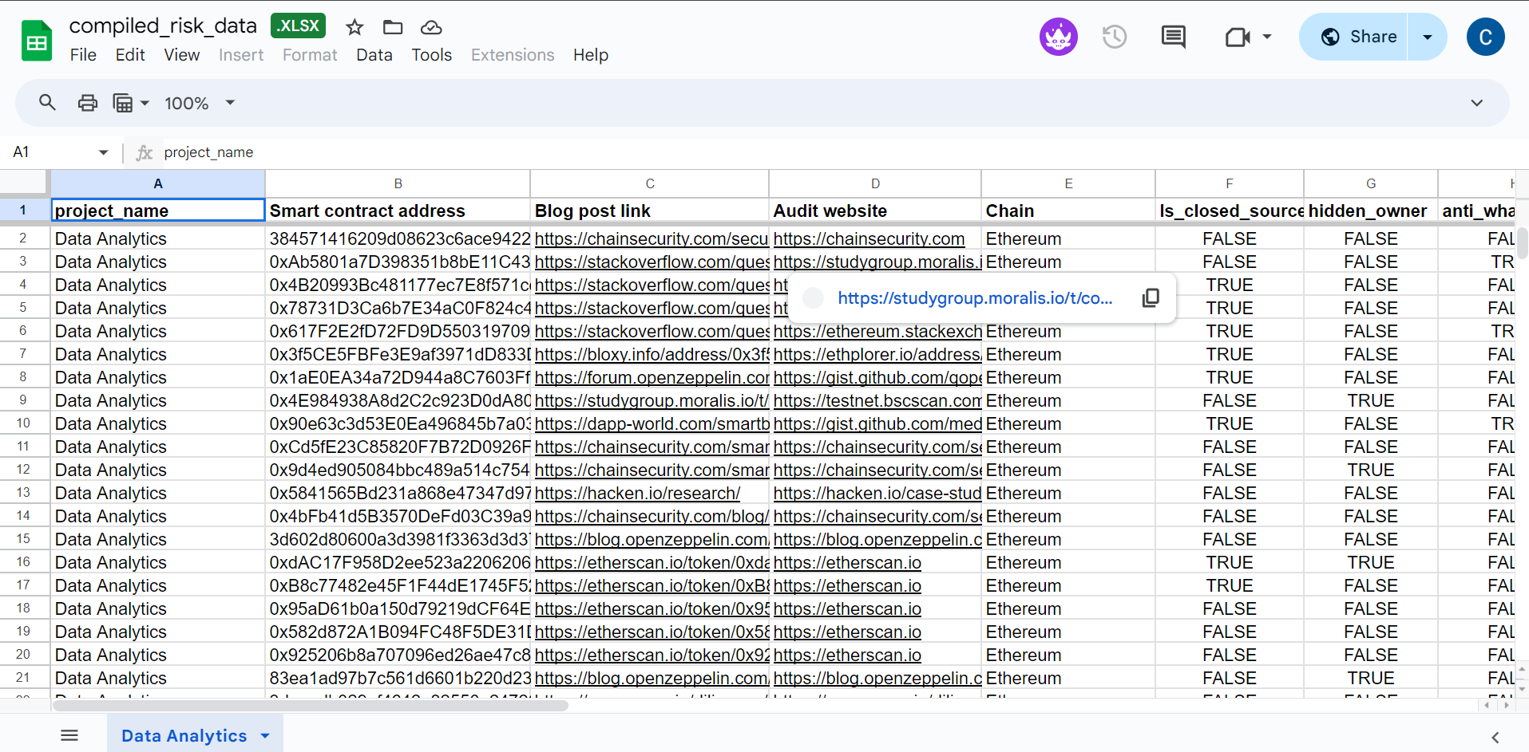

Fig 3.3.2 A screen snip of the data inputted in Excel after cleaning and sorting to enhance clarity and make it easy to draw out tables and visualise data.

**Google Colaboratory:** Using Google Colaboratory, I harnessed its data sorting capabilities to organise information logically for visualisation and reporting purposes. Sorting data within Google Colaboratory ensured the visualisations: bar charts and scatter plots effectively communicated insights. For instance, it sorted the smart contract addresses by occurrence to make it easier for the stakeholders to identify trends and make data-driven decisions.

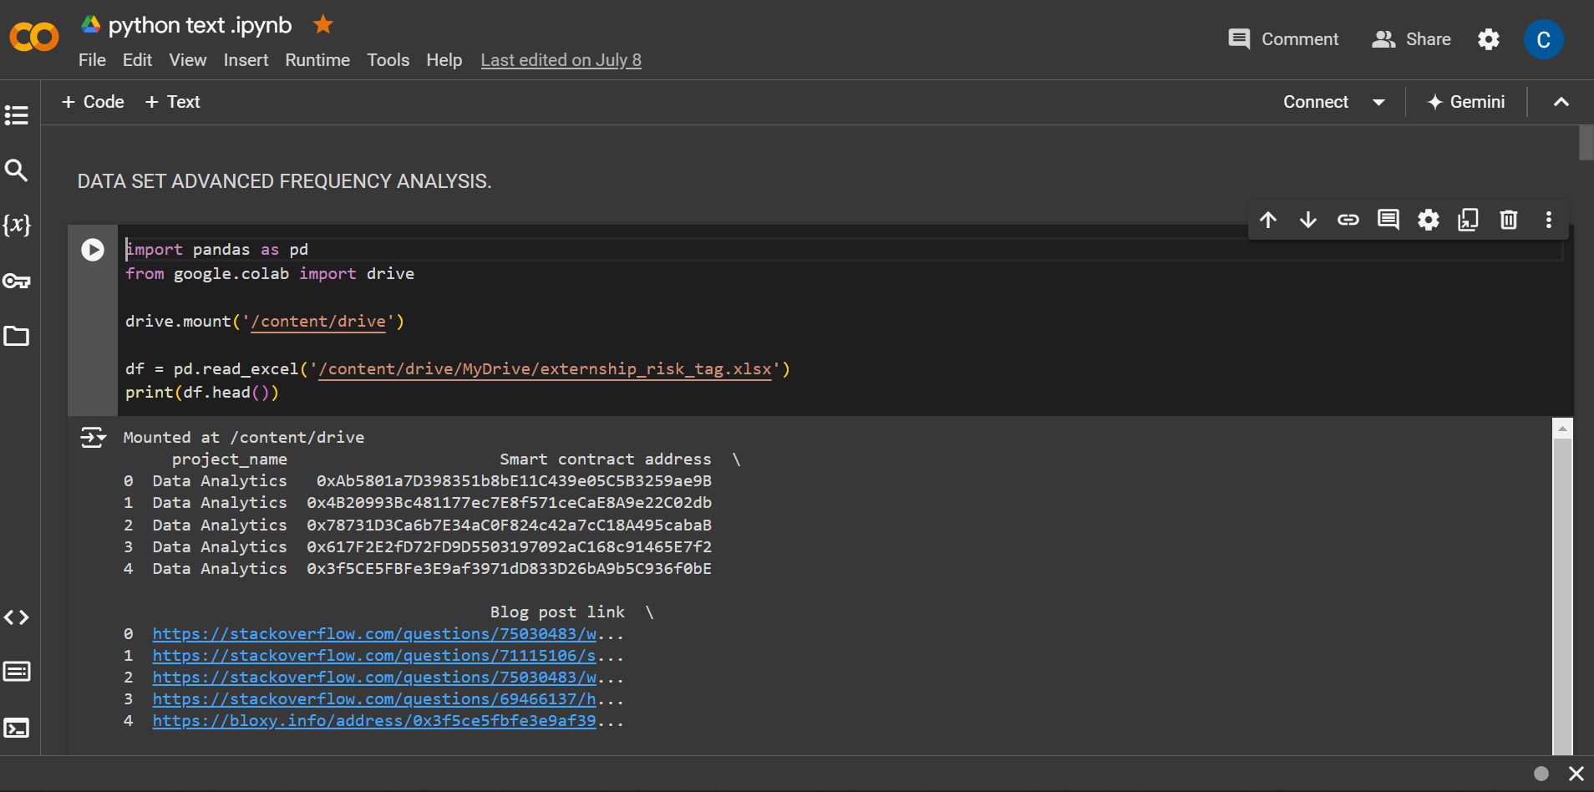

Fig 3.3.3 A screen snip of using Google Colaboratory to sort the data.

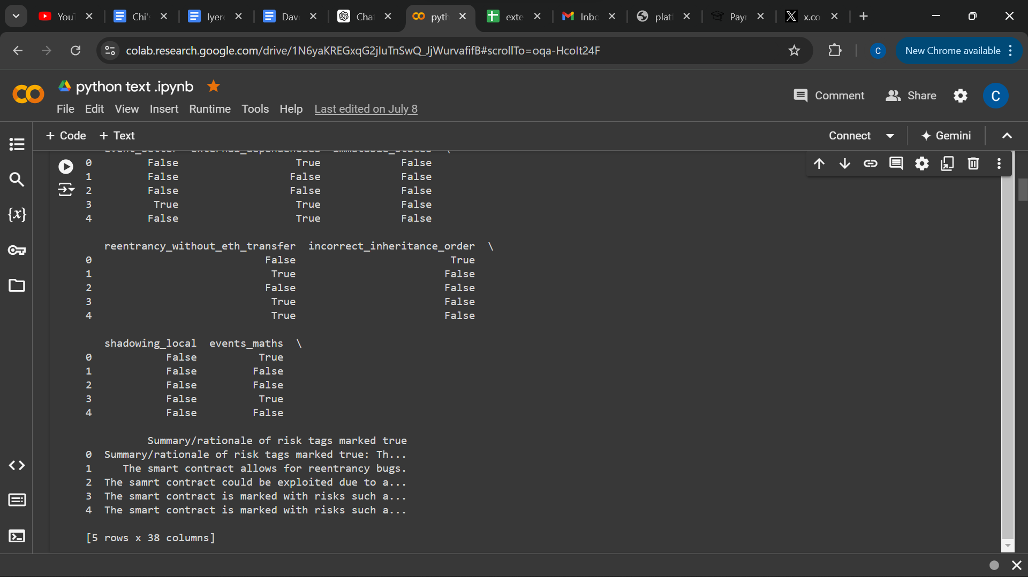

Fig 3.3.4 Sorting data on Google Colaboratory

**DATA VISUALIZATION**

Data visualization is the representation of data in a visual format such as charts, graphs, maps, and infographics.

The primary goal of data visualization is to communicate insights and patterns in data effectively, enabling faster and more informed decision-making.

During my SIWES program, I had the opportunity to harness the power of data visualization in Microsoft Excel, and Google Colaboratory to transform raw data into actionable insights. I used different types of data visualization including; bar charts, scatter plots, dendrograms and heatmap.

**Microsoft Excel**: Excel offers various chart types, including bar charts, line graphs, pie charts, and scatter plots, which I skillfully utilized to represent data visually. By selecting the most appropriate chart type for the specific dataset and analytical objective, I created compelling visualizations that facilitated a deeper understanding of trends and patterns. For instance, I developed an Excel gradebook to document the occurrence frequency of the risk tags of various smart contract addresses. Using visual representations through charts, I analyzed the results to make informed decisions regarding which risk tags were the most common and least common.

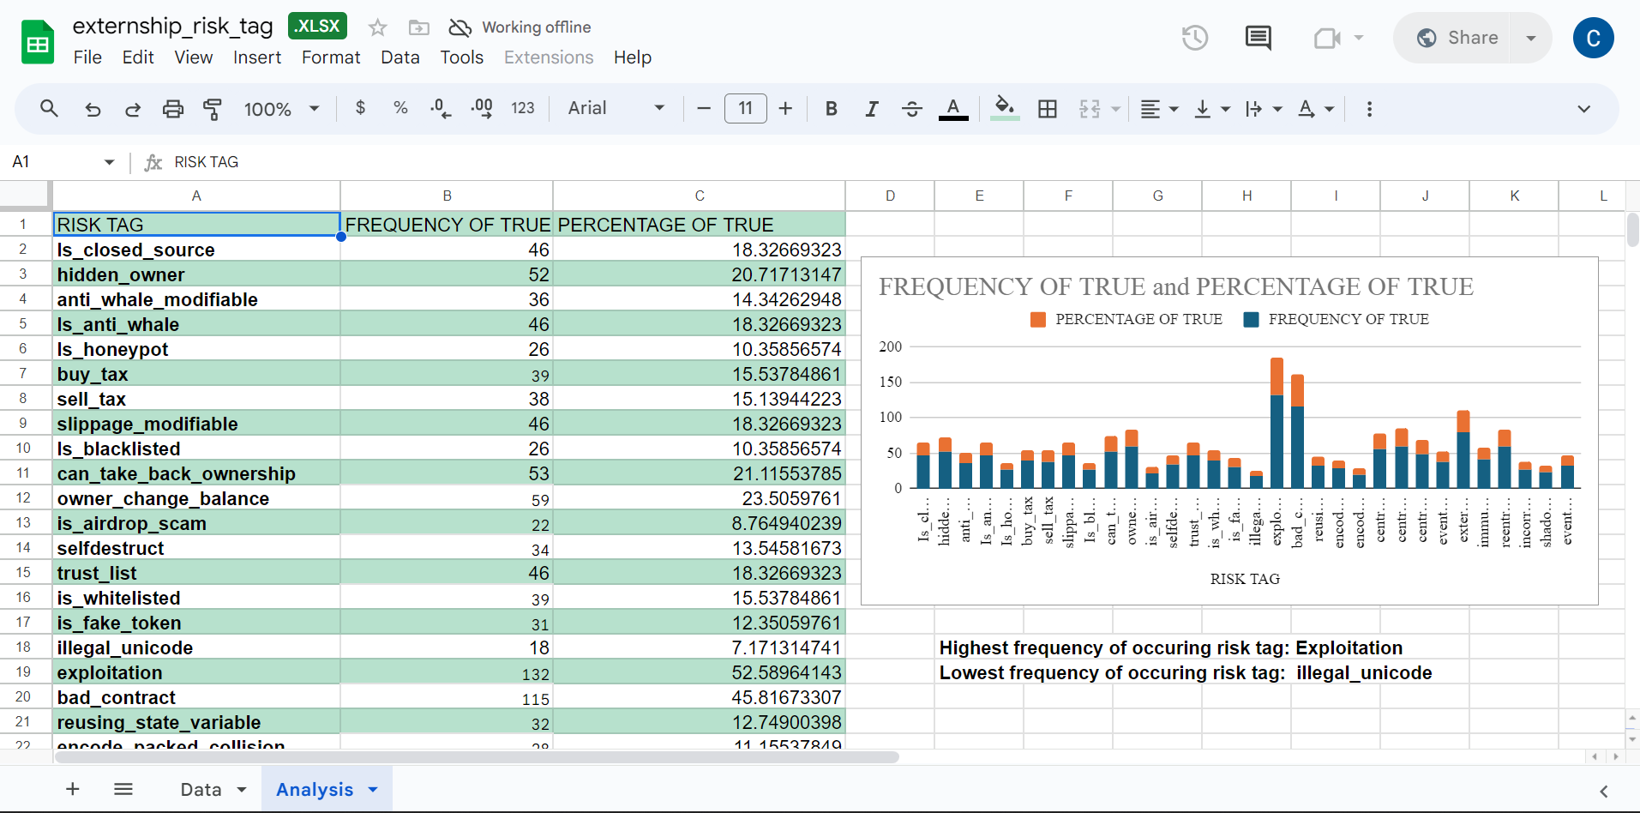

Fig 3.3.5 A screen snip of the frequency analysis in Microsoft Excel to generate insight of the highest frequency of occurring risk tag and lowest frequency of occurring risk tag.

**Google Colaboratory:** Using Google Colaboratory, with its rich visualization capabilities, enabled me to design interactive and dynamic charts. These dashboards provide stakeholders with a comprehensive view of complex datasets. To achieve this, I used some of Google Colaboratory's visualization features, such as Matplotlib, seaborn and, plotly.

During my SIWES period, I harnessed its visualization capabilities to design charts to examine the correlation between each risk tag occurrence.

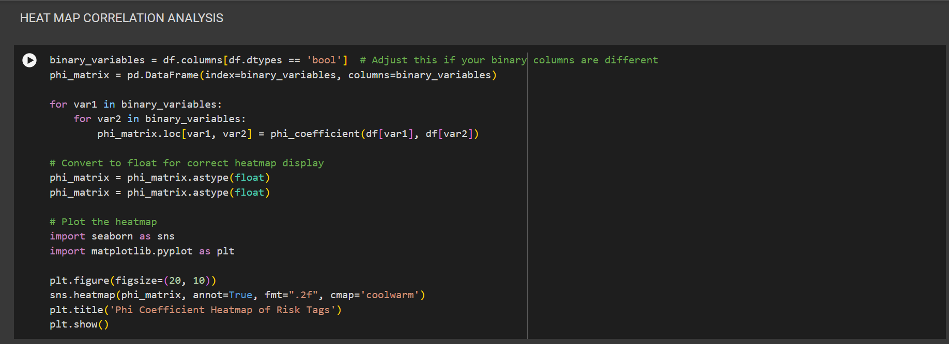

Fig 3.3.6 A screen snip of my Python code for the Heat Map Correlation Analysis on Google Colaboratory.

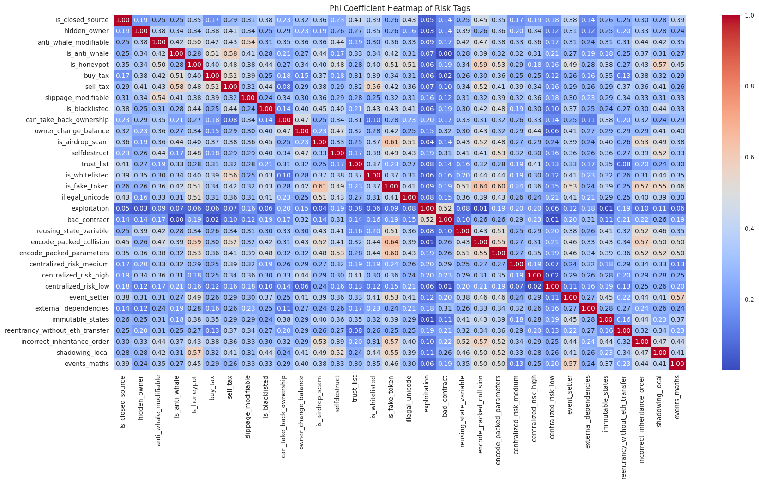

Fig 3.3.7 The PHI coefficient Heatmap of Risk tags.

The heat map correlation analysis is a visualization technique used to show the correlation between the variables by displaying a matrix of coloured squares, with colours representing the strength and direction of the correlation.

This correlation analysis type is suitable when dealing with complex data or large datasets.

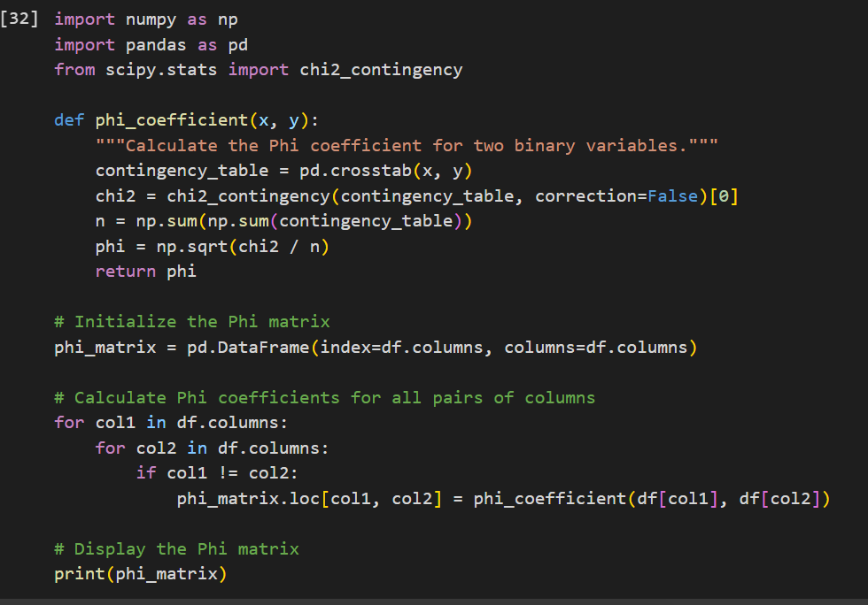

Fig 3.3.8 A screen snip of my Python code for the correlation matrix for selected features.

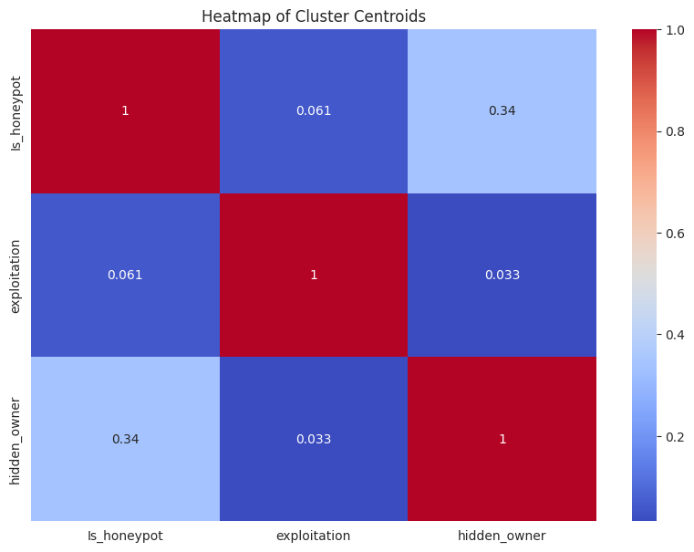

Fig 3.3.9 The heatmap of Cluster Centroids shows a correlation between the most related risk tags.

The heat map of cluster centroids is a graphical representation of cluster centroids, where each centroid is represented by a coloured square or circle, with colours indicating the density or intensity of data points within the cluster.

The primary goal of cluster centroids is to represent the central tendency of a cluster and improve clustering algorithm efficiency.

**DATA EXPORT AND SHARING**

Data export and sharing is an essential aspect of data analysis and collaboration to enable data to move between different tools and environments and share it with others for various purposes. This is to ensure the data is accessible, understandable, and secure for the intended audience.

During my SIWES program, I also gained valuable experience in efficiently exporting and sharing data using Microsoft Excel, and Google Colaboratory.

**Microsoft Excel**: Excel offers versatile options for exporting data, making it accessible to a wider audience. I frequently utilized the "Save As" feature to export worksheets or selected data ranges into various formats such as PDF(Portable Document Format), CSV(Comma- Separated Values), or even Excel (i.e. XLS, XLSX ) files. This ensured that the data could be easily shared with colleagues, superiors, or external stakeholders. Furthermore, Excel's collaboration features like sharing links and cloud storage integration facilitated collaborative data sharing and real-time updates.

**Google Colaboratory**: Google Colaboratory enhances data sharing through interactive and dynamic visualization. I created notebooks for the report and made them accessible to authorized users. Through the integration of this notebook with Google Drive, version control was provided enabling stakeholders to interact with data visualizations, fostering data-driven decisions. Google Colaboratory’s sharing and collaboration make it an effective tool for disseminating data insights and analysis workflows, facilitating teamwork, enabling knowledge sharing, and promoting reproducibility and transparency in data analysis.

**CHAPTER FOUR**

**4.1 Knowledge Gained (Experience Acquired)**

During my SIWES program at the Rivers State ICT department, I gained a diverse set of skills in network diagnostics, management information system implementation and data analysis.

In network diagnostics, I learned several troubleshooting methodologies, network architecture understanding, device configuration and packet analysis using tools like Wireshark and traceroute. I used this skill to identify and resolve network issues and packet delivery errors.

In Management Information System Implementation, I learned database management and administration of the organization, **RIVPUSMIS**. I used this skill to automate their retiring and recruitment process.

In data analysis, I learned to systematically inspect, clean, transform, and interpret data using tools like Microsoft Excel, and Google Colaboratory. These skills enabled me to draw meaningful insights from data, optimize processes, and support decision-making. These experiences equipped me with exposure to different technological tools.

Overall, my SIWES internship provided me with a comprehensive skill set spanning network diagnostics, management information system implementation, and data analysis, enhancing my proficiency in software development.

**4.2 Challenges Experienced**

Despite all productive efforts, certain challenges were encountered during the course of the practical training, hence, hindering it from being fully effective. Some of the challenges encountered include;

* Data Quality Issues: Dealing with messy or incomplete data can be challenging in data analysis, requiring thorough data cleaning.
* Data complexity: Dealing with a large data set consisting of a variety of data formats including structured, semi-structured and unstructured can be very hectic, requiring visualization.
* Security: When dealing with RIVPUSMIS, security was a serious challenge because sensitive data must be protected from unauthorised access.
* Network and Infrastructure issues: The RIVPUSMIS faced infrastructure issues which affected its reliability and connectivity.
* Project Management: Balancing multiple projects and deadlines may have been a challenge, especially when working on various tasks simultaneously.

**4.3 RECOMMENDATIONS**

* Early Placement Emphasis: Encourage students to secure SIWES placements early to provide ample time for preparation and choice selection.
* School-Organization Partnerships: Foster collaborations with IT recruiting organisations to streamline student placements.
* Flexible Internship Timelines: Allow students the flexibility to leave earlier or extend their internships for better placement options.
* Pre-Internship Support: Provide pre-internship workshops and career counselling to equip students with essential skills and help them align their interests with suitable opportunities.
* Feedback and Networking: Establish feedback channels, maintain communication during internships, and organise networking events to continually enhance the SIWES program and expand students' professional networks.

**REFERENCES**

More on SIWES

<https://www.siwes.itf.gov.ng/Identity/LandingPage/siwes#:~:text=More%20on%20SIWES&text=It%20is%20against%20this%20background,Scheme%20during%20its%20formative%20years>.

About us- ICT department

<https://www.rsbopp.rv.gov.ng/index.php/about-us/departments/ict>

Rivers State Ministry of Information and Communication

<https://www.riversstate.gov.ng/ova_dep/ministry-of-information-and-communication/>

Wikipedia (2024) List of government ministries in Rivers State

<https://en.wikipedia.org/wiki/List_of_government_ministries_of_Rivers_State>

Obkio (2023) Network Diagnostics: Solving Network Mysteries

<https://obkio.com/blog/network-diagnostics-with-obkio/#:~:text=Network%20diagnostics%20encompass%20a%20range,%2C%20bottlenecks%2C%20or%20other%20issues>.

OpenAI. (2024). *ChatGPT* [Large language model]. <https://chatgpt.com/c/66dec5c6-34b0-800f-867d-d41c728e5724>